The Weasel Activity (A Predator-Prey Simulation) NAME___________________________

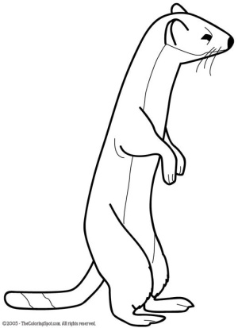

**Purpose**: to show the interaction of the growth of a predator population (weasels) with the growth of the prey population (mice).

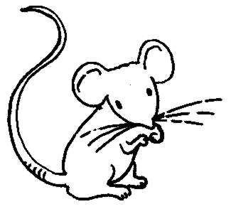Assume the following in this investigation:

* Surviving mice of each generation always double in number but NEVER grow above 100 mice. (You can assume that they emigrate out when the population gets too big.)
* A least 10 mice are present in the meadow at the start of each season (by immigration, if necessary).
* At least one weasel is present in the meadow at the start of each season (by immigration, if necessary).
* The survival of a weasel depends upon its ability to catch at least 5 mice. If the weasel does not catch 5 mice, it will die or leave the field.
* A weasel can produce one offspring for every 5 mice that it catches.

**Materials**: The mice (prey) will be represented by small beans. The weasels (predators) will be represented by spoons. The field will be one a petri dish.

**Procedure**:

1. Place 10 mice (beans) in the field (dish). This is your **“Initial Prey”**. Assume there is one weasel (spoon) in the field. This is your **“Initial Predator”**. Record your starting population data in Data Table.
2. Make one pass through the dish with the spoon. Count the number of mice caught and record this number in the Data Table under **“Prey Captured”.**
3. Then in the same table, summarize the number of **“Prey Survivors”**, **“Predator Survivors”** (1 for every 5 mice caught), and the number of **“Predator Offspring”** (1 for every 5 mice caught).
4. Double the number of **“Prey Survivors”** and put that number in the Generation 2 of **“Initial Prey”**. Put that number of beans in the dish.
5. Add the number of **“Predator Survivors”** and **“Predator Offspring”**. Put that number in Generation 2 of **“Initial Predators”**. This tells you how times you should scoop through the field hunting for prey.
6. Repeat steps 2-5 for a total of 20 generations. Remember to make one pass of the spoon for each weasel present at the beginning of each generation. BE SURE TO KEEP THE MICE CAUGHT BY EACH WEASEL IN A SEPARATE PILE. DO NOT put the beans back in the dish after one weasel has “caught” them. Those mice are in the first weasel’s belly and cannot be running around the field for the next weasel!
7. Graph your initial prey and initial predators for each generation. You will have two lines.

The Weasel Activity (A Predator-Prey Simulation) NAME___________________________

Purpose: to show the interaction of the growth of a predator population (weasels) with the growth of the prey population (mice).

Data : Summary of Predator-Prey Numbers

Generations

|  |  |  |  |  |  |  |  |  |  |  |  |  |  |  |  |  |  |  |  |
| --- | --- | --- | --- | --- | --- | --- | --- | --- | --- | --- | --- | --- | --- | --- | --- | --- | --- | --- | --- |
|  | 1 | 2 | 3 | 4 | 5 | 6 | 7 | 8 | 9 | 10 | 11 | 12 | 13 | 14 | 15 | 16 | 17 | 18 | 19 |
| Initial  Prey  *(graph)* | **10** | **20** | **30** | **50** | **68** | **100** | **100** | **100** | **10** | **10** | **16** | **10** | **20** | **40** | **50** | **38** | **16** | **10** | **10** |
| Prey  Captured | 0 | 5 | 5 | 16 | 18 | 40 | 50 | 96 | 10 | 2 | 5 | 0 | 0 | 15 | 31 | 30 | 16 | 8 | 6 |
| Prey Survivors | 10 | 15 | 25 | 34 | 50 | 60 | 50 | 4 | 0 | 8 | 5 | 10 | 20 | 25 | 19 | 8 | 0 | 2 | 4 |
| Initial  Predators  *(graph)* | **1** | **1** | **2** | **2** | **3** | **3** | **9** | **18** | **16** | **1** | **1** | **2** | **1** | **1** | **4** | **7** | **10** | **2** | **1** |
| Predator  Survivors | 0 | 1 | 1 | 1 | 1 | 3 | 9 | 6 | 0 | 0 | 1 | 0 | 0 | 1 | 3 | 3 | 1 | 0 | 1 |
| Predator  Offspring | 0 | 1 | 1 | 2 | 2 | 6 | 9 | 10 | 0 | 0 | 1 | 0 | 0 | 3 | 4 | 7 | 1 | 0 | 1 |

BE SURE TO DO YOUR GRAPHING!

**Questions: Answer the following in complete sentences.**

1. Which population, predator or prey, shows the first increase in size?

2. What is the relationship between peaks in the two populations?

What is the reason for this relationship?

3. What is the determining factor for the size of the weasel population?

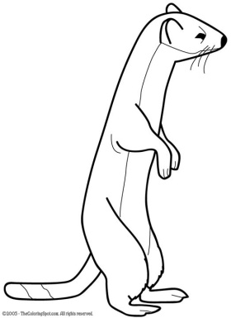

4. If another predator (for example, a hawk) moved in and started eating mice also, what would be the effect on the mouse population size?

What would be the effect on the weasel population size?

You will plot your data on this semi-log graph paper. The “y” axis is numbered 1-10 on the lower half and then the numbers on the upper half are actually 10-100. So your weasels will mainly be graphed on the lower half and your mice on the upper half. This should allow you to see the relationship between the growths of both populations.

TITLE _______________________________________________________________



1 2 3 4 5 6 7 8 9 10 11 12 13 14 15 16 17 18 19

Generations