Pedigree Inquiry Name ________________________
Date __________________ Per ___

Directions: Use the pedigrees attached to answer the following questions in complete sentences.

Overview: A pedigree chart demonstrates the inheritance of a particular trait in a family. Females are represented by a circle, males by a square. A shaded circle or square represents that the individual has the particular trait or disorder expressed in their phenotype. Horizontal lines represent marriages, and vertical lines represent their offspring. Recessive traits can skip a generation, while dominant traits tend not to. If there are more males with a particular trait than females, the trait is probably sex-linked. Genotypes for sex-lined traits must be written as superscripts on the X chromosome. Mothers with a sex-linked recessive trait will always have sons with the trait. If any males in the family are carriers, then the trait is autosomal. If the trait is autosomal, you must write the genotypes using only lower and uppercase letters.

Part I: The Ling Family
Use the pedigree in Figure 1 to answer the following questions about the inheritance of colorblindness in the Ling family.

1. How many males in this family are colorblind?

2. How many males are normal?

3. How many females are colorblind?

4. How many females are normal?

5. Is colorblindness a sex-linked or autosomal trait? Explain how you can determine this from the Ling family pedigree.

6. How many generations are present on this pedigree?

7. How many children did the couple in the first generation have?

8. List the genotypes for all males in the Ling family. (B – normal, b – colorblind)

9. What is the genotype of a colorblind female? Which females in the Ling family are colorblind?

10. List the carrier females and give the genotype.

11. Is there any chance of individuals 3 and 4 having a colorblind son? Explain.

12. If individual 20 marries a carrier female, what would be the possible offspring? (Show the cross.)

Part II: The Paul Family
Use the pedigree in Figure 2 to answer the following questions about the inheritance of Huntington’s in the Paul family.

1. Is the inheritance of Huntington’s a sex-linked or autosomal trait? Explain how you can determine this from the Paul Family pedigree.

2. Is Huntington’s a dominant or recessive trait? Explain how you can determine this from the Paul Family pedigree.

3. Are there carriers of the Huntington’s trait in the Paul family? Why or why not?.

4. What would be the possible offspring if individual II-5 married a person who was normal? (Show the cross)

5. For which individuals do you need more information before determining their genotype?

Figure 1-The Ling Family Pedigree

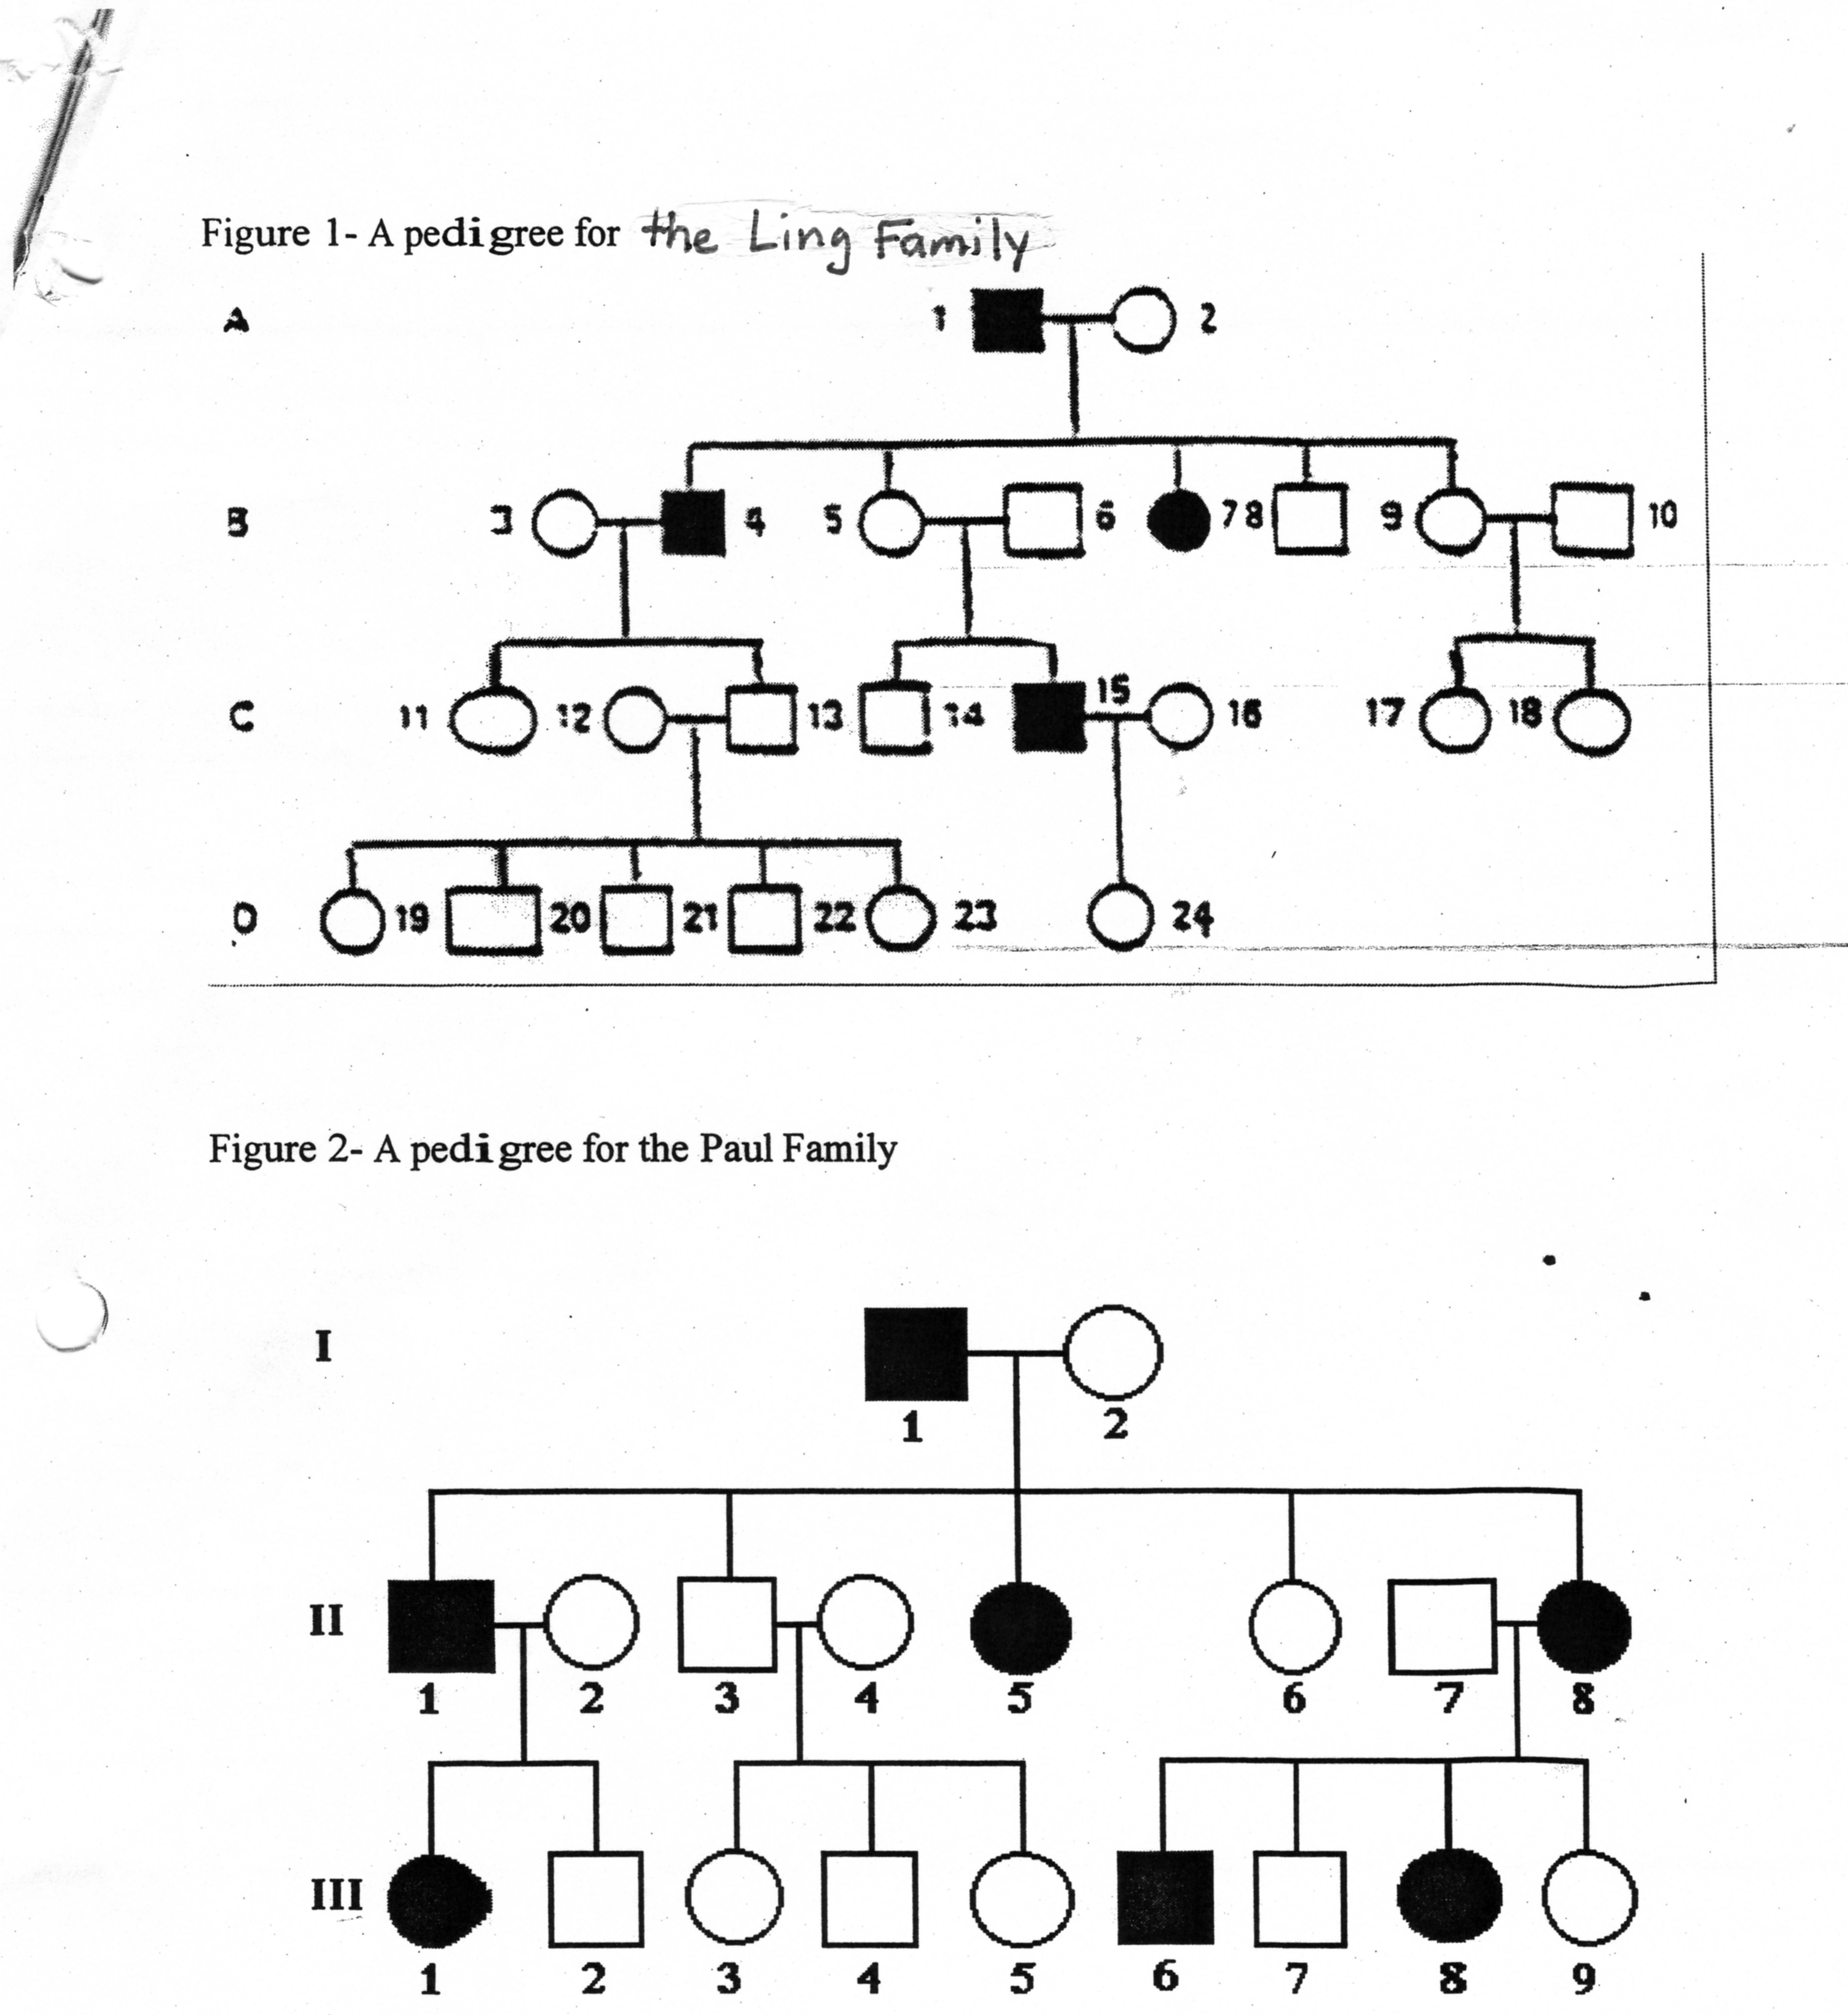

Figure 2 – The Paul Family Pedigree

